Our Announcement & Donations Service
Our service adds a funeral announcement to our website home page and announcement page as soon as arrangements are finalised. This provides instant information for mourners and includes full printable service details.
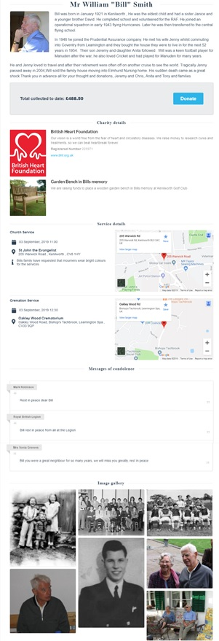
The announcement leads to an obituary page which provides the opportunity for a biography with or without pictures. If you would like a biography and or photographs added, please send both to us, ideally via email.
Full details of the charity or causes you have selected are shown, together with links to their websites for more information. You can collect not only for registered charities but also local groups or more personal tributes - as in the case shown - a garden bench to be placed at the cricket ground.
Donations can be made for a period of 4 weeks from the funeral. The pages are online 24x7 allowing donors to donate from anywhere at any time.
Donating online makes it easy to add Gift Aid in a single click and typically 80% of online donors do, boosting each donation by 25%.
Online donors can also leave a condolence message and typically around 90% of donors do. You can view these online at any time and we will also send you all of the messages along with a list of donors and the total raised at the end of the collection period.
Donors can of course still donate in the traditional way at the service or by sending us a cheque made payable to the charity. However, to add Gift Aid they will need to complete a Gift Aid form and send it with their donation. Gift Aid forms can be downloaded from our website or collected from our office.
When the collection closes, the online page is removed, but if you wish we can put the page online again, without the service information or the ability to donate.
We send the list of donors and funds to the charity shortly after closing the collection, requesting that the charity or causes write to you to confirm receipt of the funds.
We make no deduction from any donation other than the card transaction costs charged to us.

